# CS 255 System Design Document

This template lays out all the different sections that you need to complete for Project Two. Each section has guidance to prompt your thinking. You will need to continually reference the interview transcript as you work to make sure that you are addressing your client’s needs. There is no required length for the final document. Instead the goal is to complete each section based on what your client’s needs are. Remove this note when you are finished, and replace all bracketed text with the relevant information.

## UML Diagrams

### UML Use Case Diagram

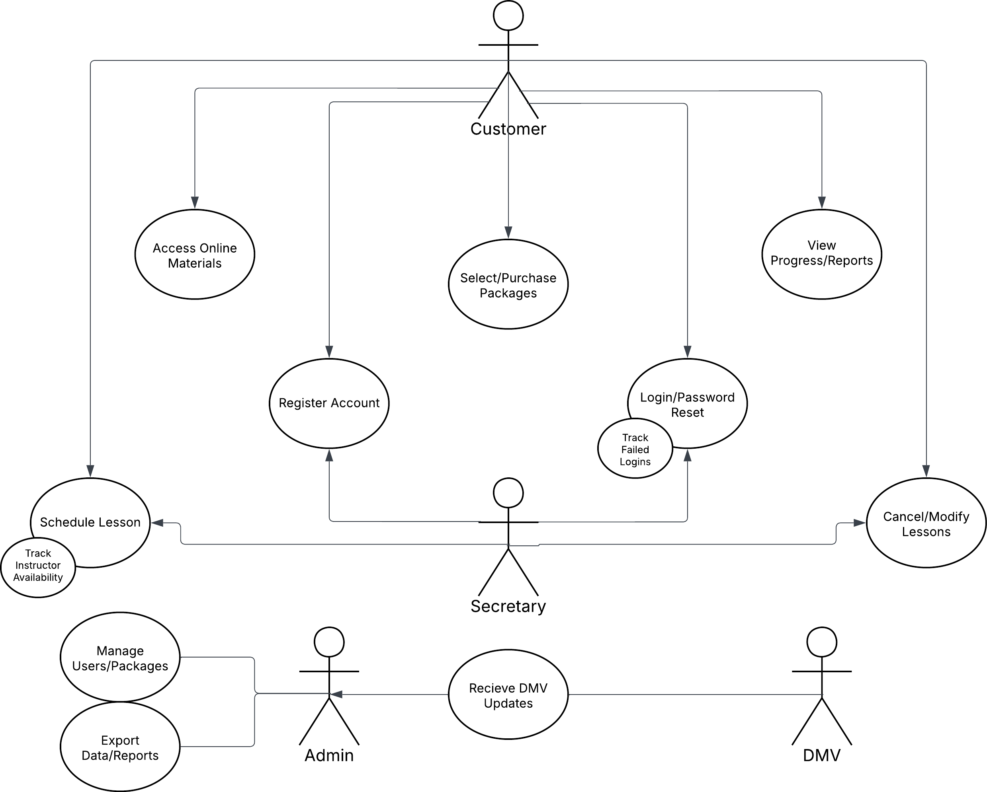

### UML Activity Diagrams

User Login Process/Appointment Scheduling:

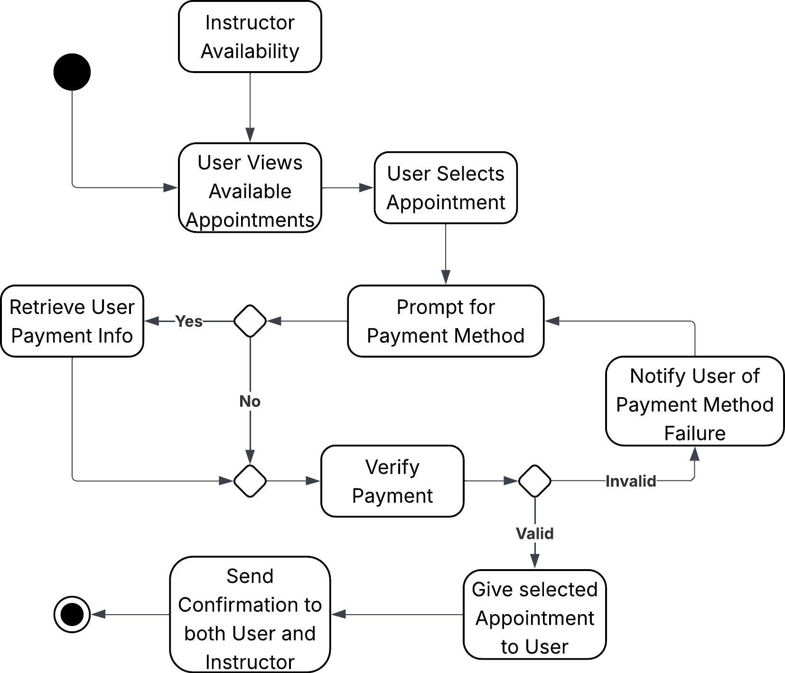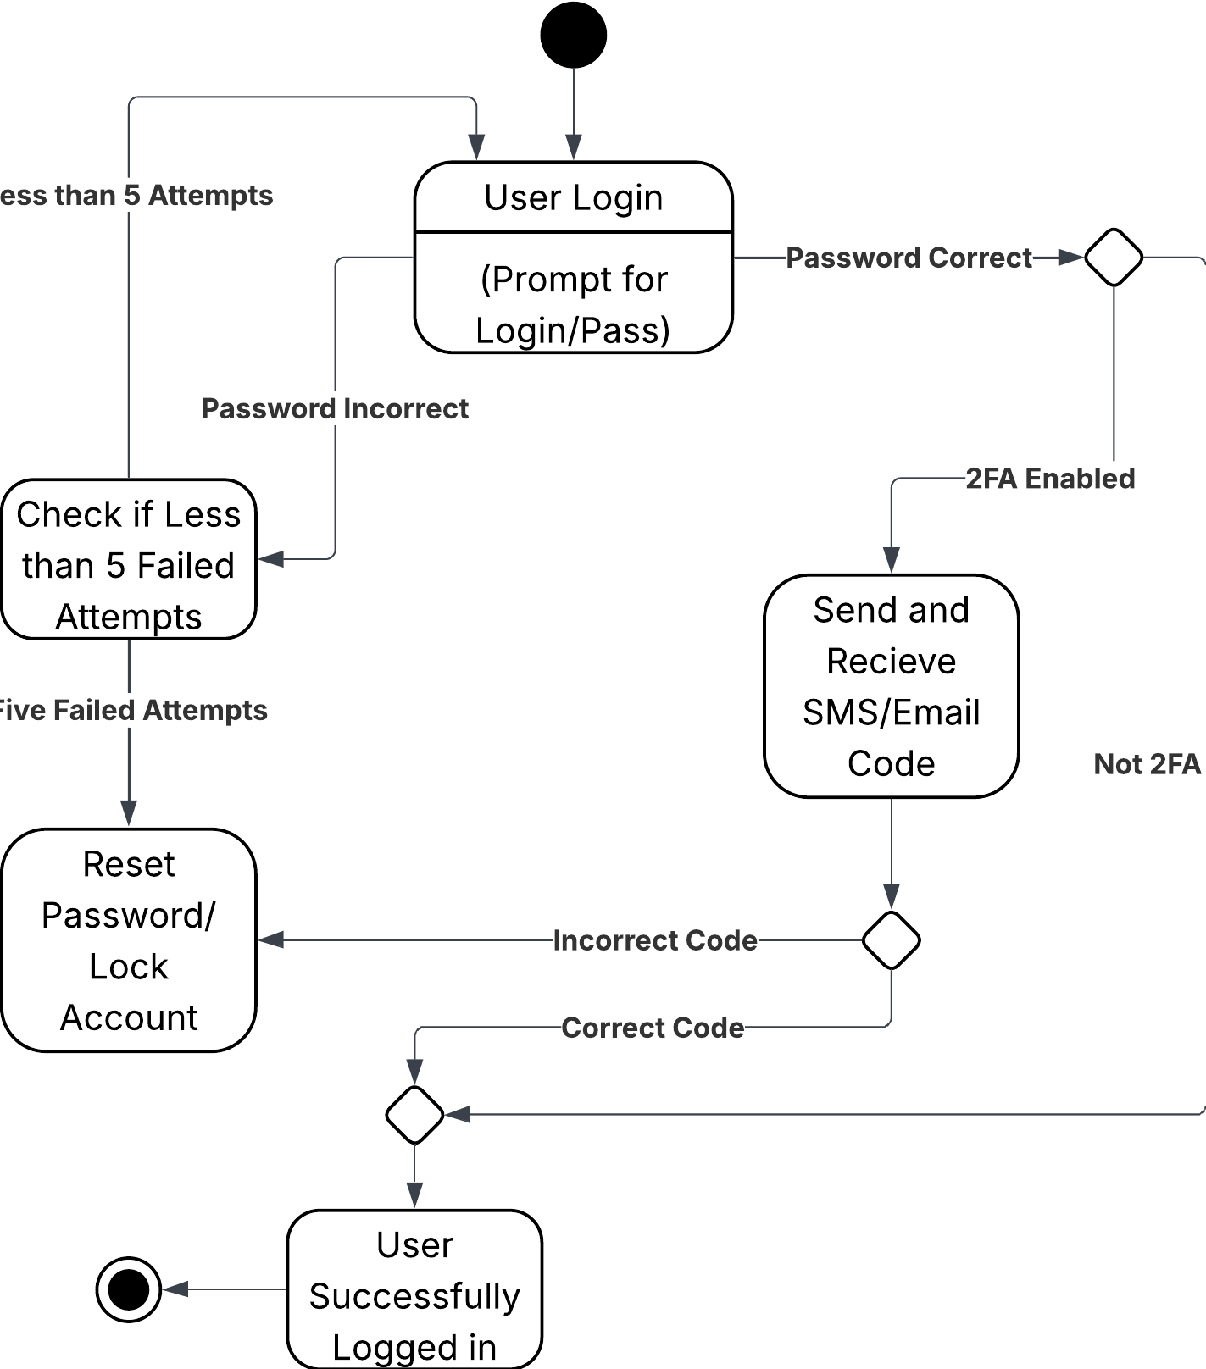

### UML Sequence Diagram

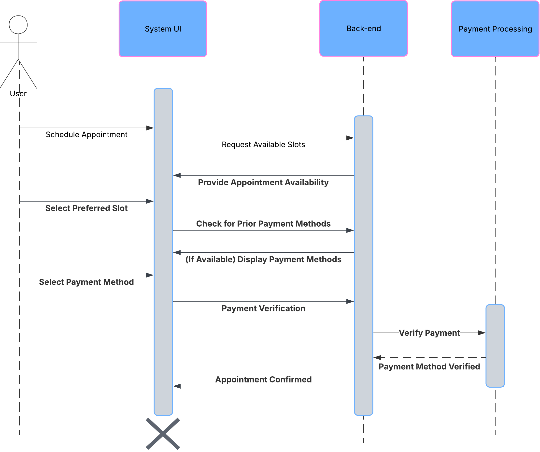

### UML Class Diagram

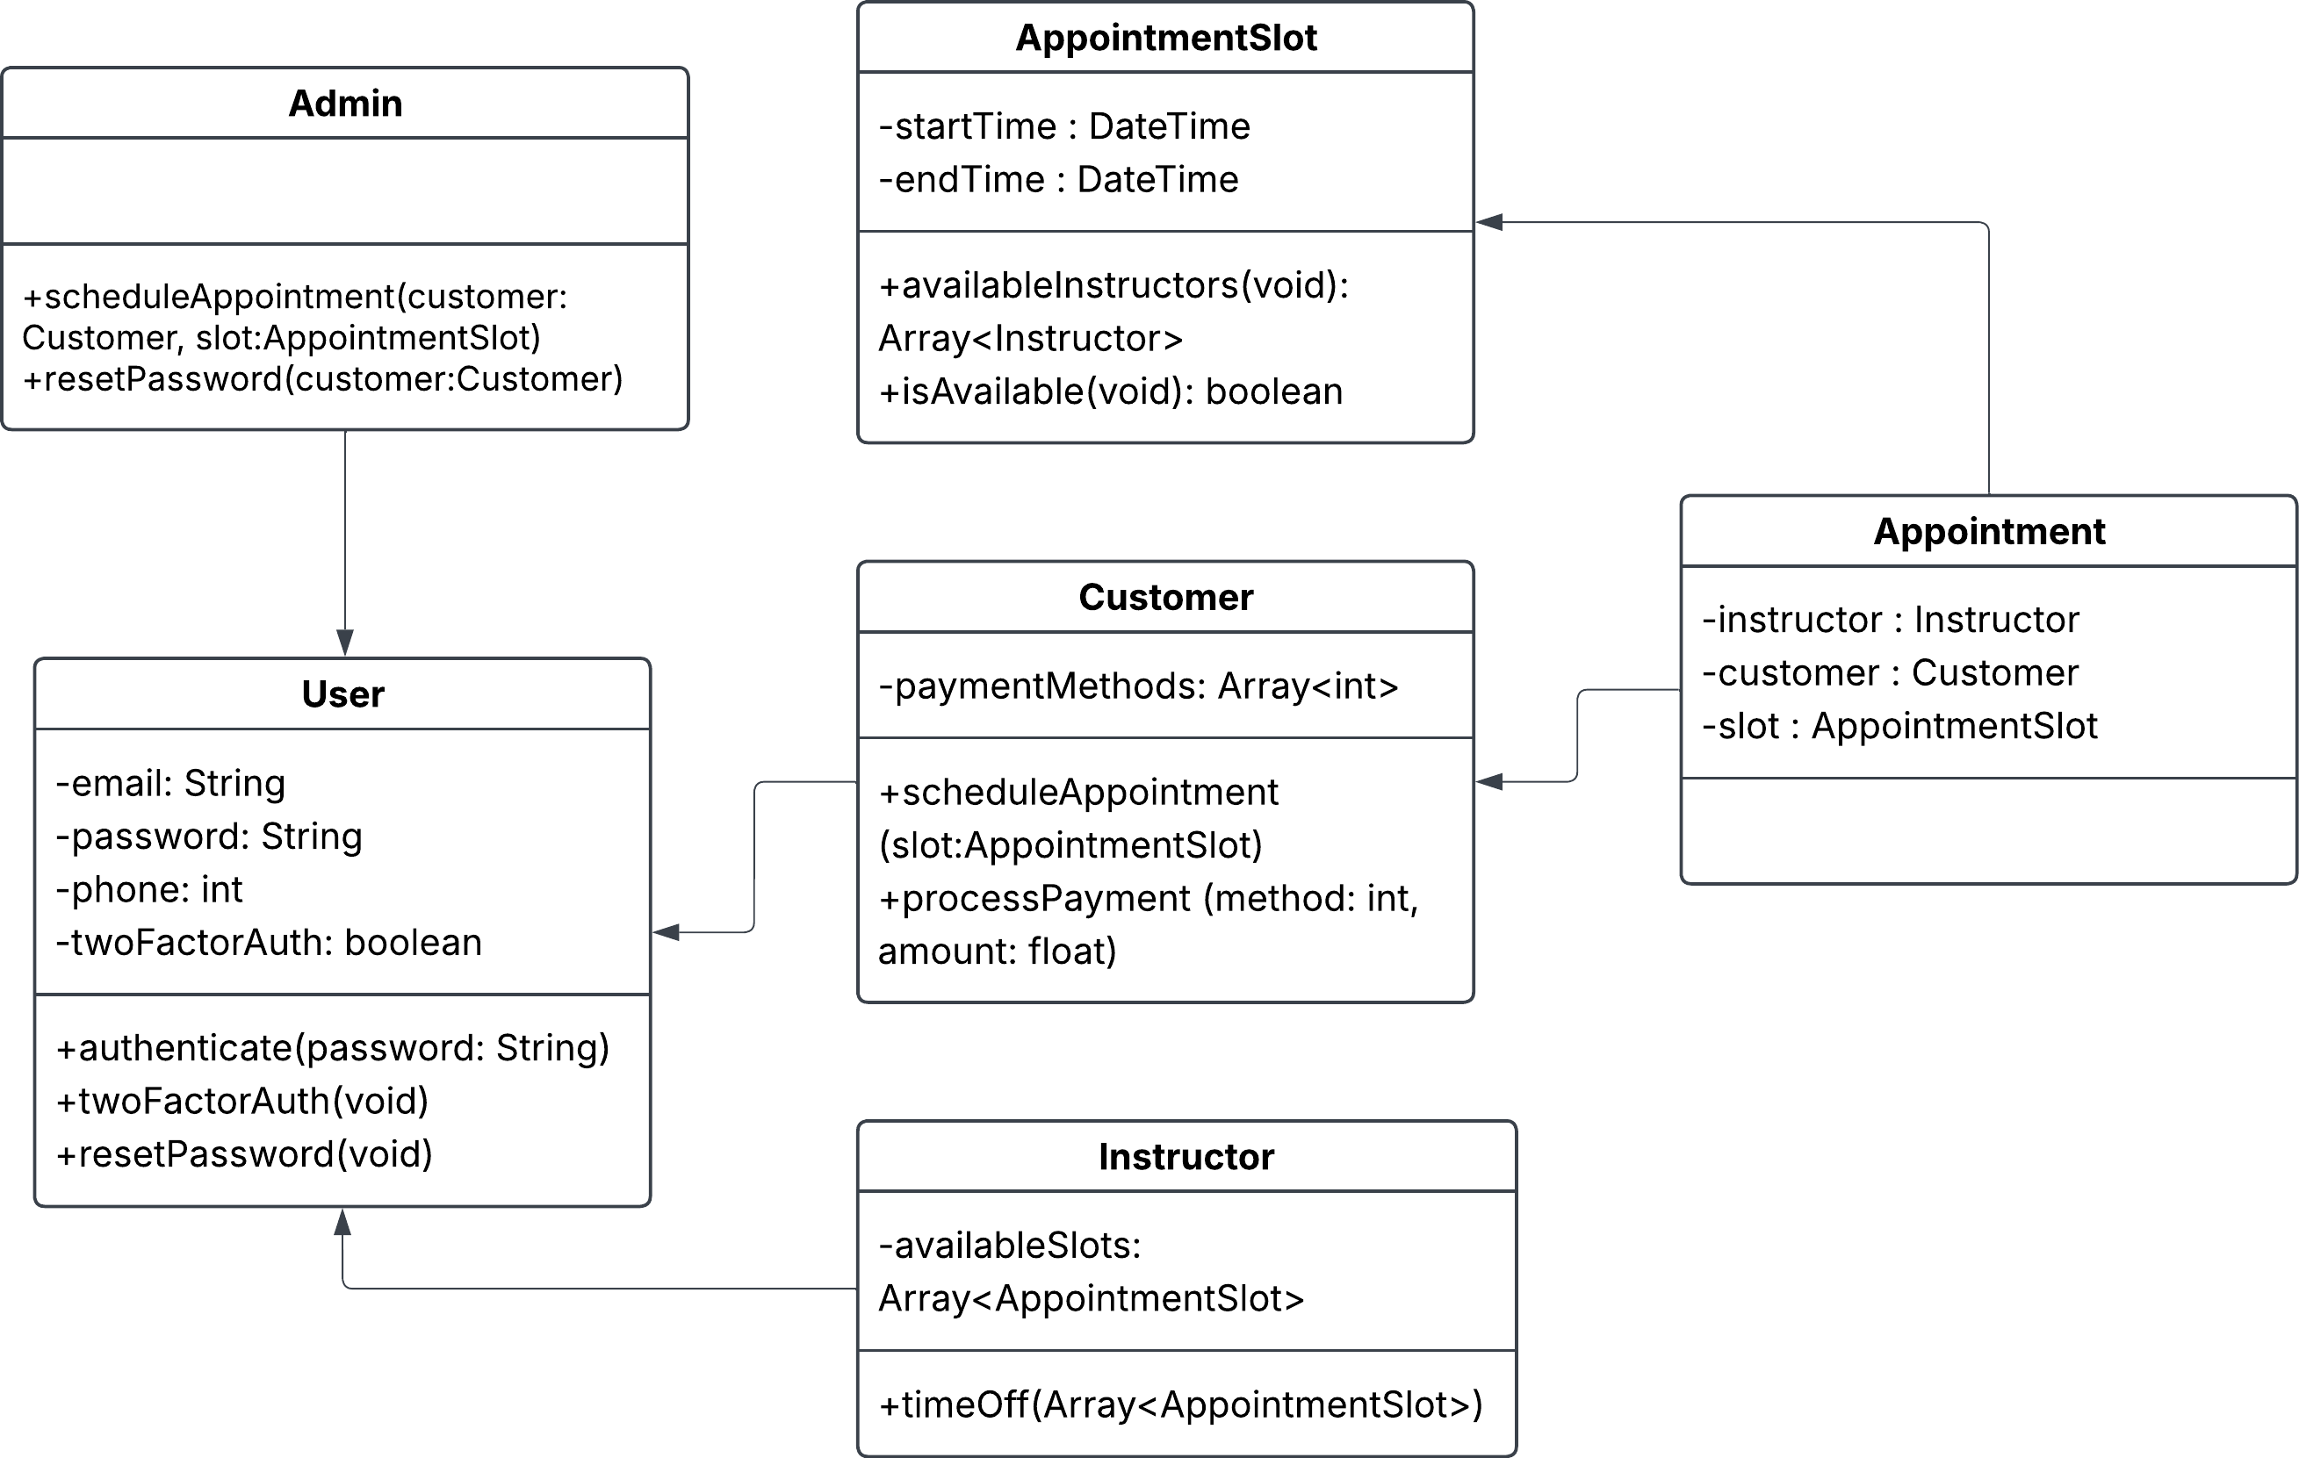

## Technical Requirements

System Architecture:

The system will have three main parts:

- User Interface (UI): This is where customers interact with the system to schedule lessons, view reports, and purchase packages.

- Backend: This part will handle user data, lesson tracking, and payment processing.

- Payment Processing: A secure system to handle payments and validate transactions.

User Authentication:

- The system will use two-factor authentication (2FA), like SMS or email codes, to make logins more secure.

- Password Management: Users should be able to reset their password if they forget it or after multiple failed login attempts (5).

- Login Attempts: The system will limit login attempts to five tries. After that, the account will be locked and the user will need to reset their password.

Appointment Scheduling:

- Users can view available instructor slots and select the one they want.

- The system will check that the instructor is available before confirming the appointment.

- Users will need to provide payment information before their appointment can be confirmed.

Payment Processing:

- The system will support different payment methods (like credit cards) and will securely verify payment information.

- If the user doesn’t have payment information stored, they will be asked to enter it.

- Payment must be confirmed before an appointment is finalized.

Database Design:

- User Data: The system will store user information like email, password, phone number, and two-factor authentication settings.

- Instructor & Appointment Data: It will track instructor availability, scheduled lessons, and appointment details.

- Payment Records: It will store information on payment methods, transaction amounts, and confirmation statuses securely.

Error Handling:

- The system will provide clear error messages for failed actions (like a failed login or invalid payment method).

Security Requirements:

- User passwords must be stored securely using encryption techniques (like hashing and salting).

- All communication between the user and the system must be encrypted with TLS/SSL to protect user data.

- Payments will be processed using PCI DSS-compliant services to ensure secure transactions.

Performance & Scalability:

- The system must handle multiple requests at once and be able to scale as the number of users and appointment requests grows.

- Database queries, especially for logging in and verifying payments, need to be optimized for speed and performance.

User Experience:

- The UI should be easy to use, responsive, and work well on different devices (desktops, tablets, and phones).

- Users will get confirmation emails or SMS notifications when their appointment is successfully scheduled or payment is processed.

Regulatory Compliance:

The system must follow data protection regulations (like GDPR or CCPA) to make sure user information is stored and handled securely.